Early Textiles Study Group courses
Our Group offers an in-person practical course in English on how to identify and describe the structure of textiles. It is suitable for historians, archaeologists, anthropologists and craftspeople. The Group’s aim is to increase the competence and confidence of people who have to describe textiles as part of their employment or research.
The course is made up of two parts, each two weeks long. Part 1 covers simple weaves and non-woven structures. Part 2, for people who have taken Part 1 or have equivalent experience, is on complex weaves defined as made on a loom with a figure harness. We are hoping to develop two shorter complementary courses, on fibres and on yarns and finishes.
Part 1 sessions are held in Slaithwaite near Huddersfield, West Yorkshire. Places are available on both of our 2024 Part 1 sessions. The first is 8-12 and 15-19 April and the second 8-12 and 15-19 July. A single Part 2 session will take place 19-24 and 27-30 August, probably in Macclesfield, Cheshire. In both places it is possible to see looms appropriate to the course.
The tutors for Part 1 are Hero Granger-Taylor, archaeologist, and Ruth Gilbert, weaver. For Part 2 the principal tutor is Sophie Desrosiers, EHESS Paris, formerly tutor for the CIETA Technical Sessions. There is a maximum of 10 students per session. The fees are £500 for Part 1 and £550 for Part 2, but please contact us if the cost would prevent your attendance. Fees do not include meals or accommodation.
For course content, see https://www.earlytextilesstudygroup.org/etsg-courses.html . For further information, please contact Ruth Gilbert, plainweave879@btinternet.com , and Hero Granger-Taylor, hero@granger-taylor.com .
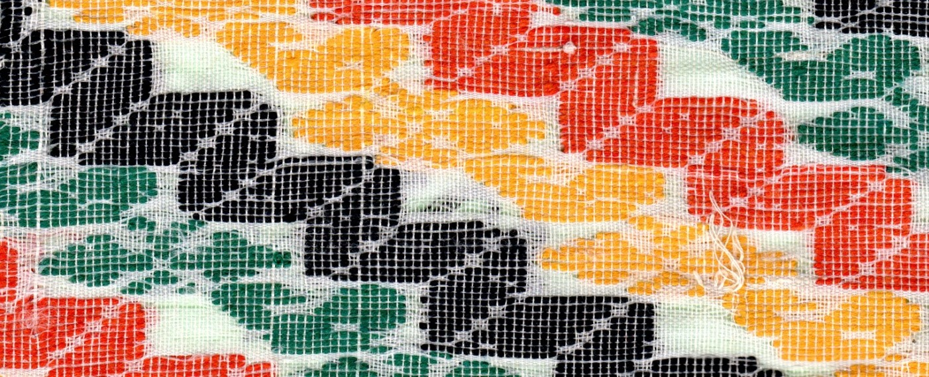
Detail of a traditional Bengali jamdani cotton muslin. The woven structure is similar to silk fragments of c.800 AD from the grave of St Cuthbert at Durham.

